***Hill Lane Surgery***

***Newsletter***

***July 2021***

***Hello and welcome to our newsletter.***

***We want to assure you that we are still here for your health needs. It is especially important to remember that there are health problems other than COVID-19 that you may need help with and that if you have a medical emergency you still need to access urgent healthcare. Please do not put off contacting us if you have a medical need, sometimes contacting us can prevent a hospital admission if we can treat you promptly. You can contact us via e-consult or telephone and we will conduct a remote assessment. This may mean we respond to queries via email, phone you or conduct a video consultation with you.***

***If you need to be seen face to face we can arrange to do this safely, following national guidance to minimise the risk of infection. We also have the ability to discuss your care with hospital specialists when needed. The hospital is still “open for business” and if you need hospital care we can support you with this.***

***Outside of our opening hours, if you have an urgent medical (physical or mental health) need please visit https://111.nhs.uk/ or call 111 if you cannot access the website.***

***If you develop symptoms of COVID 19 (new, continuous cough, fever ≥37.8) please go online or call 111 directly.***

***INFORMATION FOR PATIENTS REGARDING***

***COVID-19 INFECTION (CORONAVIRUS)***

***For all those who develop relevant symptoms ( for example respiratory symptoms, shortness of breath, cough, fever, loss of sense of smell or taste) however mild***

***SHOULD NOT ATTEND THE PRACTICE***

***Stay indoors and avoid contact with other people immediately***

***Patients should remain at home and arrange a covid test:***

***https://www.gov.uk/get-coronavirus-test***

***Carers***

***Carers who are registered with a Southampton GP Practice are being urged to register as a carer with Carers in Southampton if they have not done so already, to be on the priority list to receive the COVID-19 vaccination.***

***Tell Carers in Southampton by calling 0870 315 6547 (Lines are open Monday to Friday 9am-5pm). More information can be found on the Carers in Southampton webpage.***

***Carers will be contacted directly by the NHS when it is their turn to be vaccinated***

***Click on the following link for general information***

***https://www.nhs.uk/conditions/coronavirus-covid-19/***

***ISOLATION NOTE***

***If you require a self-isolation note for your employer please click on the link below. We cannot issue you with a sick note or a letter:***

***https://111.nhs.uk/isolation-note/?fbclid=IwAR0X_JFsjkMBJrkHrQlcF4iy0dJ5zsIaI7dubF6-Dz7dvAEgxEVLmEw75JM***

***LETTER FOR PATIENTS WHO ARE CONCERNED ABOUT THEIR CHILDREN RETURNING TO SCHOOL***

***Guidance note for parents***

***In light of the COVID-19 situation LMC Law has sent us the following information, set out below, that practices may wish to use in terms of updating their Privacy Notices.***

***Following the latest Notice issued by the Department of Health & Social Care, under Regulation 3(4) of The Health Service (Control of Patient Information) Regulations 2002, we have revised the information that we originally provided in respect of Practice Privacy Notices and the Covid-19 pandemic as follows:***

***Now the percentage of people who have been fully vaccinated are on the rise we would like to let you know that the NHS App is a great way to show proof of vaccination. We would recommend you download the NHS app. This App not only shows vaccination dates etc, but you can also request repeat prescriptions and book appointments.***

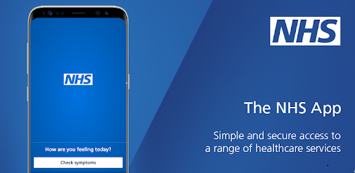

***Kind Regards***

***Laura***

***Practice Administrator***

***Hill Lane Surgery***

**'Try the new NHS App’**

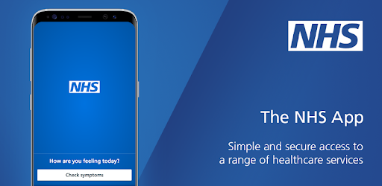

You can now use the new NHS App, a simple and secure way to access a range of NHS services on your smartphone or tablet.

You can use the NHS App to check your symptoms and get instant advice, book appointments, **order repeat prescriptions,** view your GP medical record and more.

If you already use our Hill Lane website, you can continue to use it. You can use the NHS App as well.

For more information go to www.nhs.uk/nhsapp

(You might also need to review existing website content to make sure it covers the different options patients have to connect with online services.)



[**https://www.jostrust.org.uk/about-us?gclid=CjwKCAiAhfzSBRBTEiwAN-ysWIVlPzyexe1oe2o5AZ3ZG0S500W5xKV9ymS5hBKyq90IyKuUZhqHARoCWPkQAvD_BwE**](https://www.jostrust.org.uk/about-us?gclid=CjwKCAiAhfzSBRBTEiwAN-ysWIVlPzyexe1oe2o5AZ3ZG0S500W5xKV9ymS5hBKyq90IyKuUZhqHARoCWPkQAvD_BwE)

Please call the surgery to book an appointment if your smear is due. Please click on the link above for more information, and answers to lots of questions about cervical screening.

"A smear test lasts 5 minutes. The Impact of cervical cancer lasts a lifetime"

Attend your smear test.

**Reduce your risk.**

**[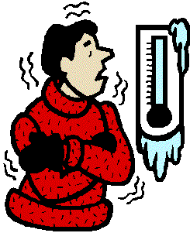](http://www.cliparthut.com/cold-weather-clip-art-clipart-9AMocS.html)**

***Keep Warm, Keep Well***

**Cold homes can have a big impact on your health, and one of the most effective ways of keeping well during winter is to stay warm. This can help prevent colds and flu, as well as more serious conditions, including pneumonia, heart attacks, strokes and depression.**

**Try some of these tips to help keep you warm this winter:**

**✓Draw your curtains at dusk and keep doors closed to block out draughts.**

**✓Have hot drinks regularly, and eat at least one hot meal a day if you can. By eating regularly you can keep energy levels up during winter.**

**✓Instead of wearing one chunky layer of clothing, wear several light layers of warm clothes.**

**✓Keep active in your home if possible, movement will help keep you warm. Wear shoes with a good grip if you need to go outside on cold days.**

**✓Keep your bedroom at 18°C and main living room at 21°C (65 and 70°F). If you can’t heat all the rooms you use, heat the living room during the day and the bedroom just before you go to sleep.**

**✓Try to go and see friends, relatives or neighbours who may be vulnerable to cold weather. Cold weather is especially dangerous for older people or people with serious illnesses, so check up on them if you can. (Bearing in mind Covid restrictions.)**

**For more information on keeping warm and well, visit the following NHS website**

**https://www.nhs.uk/live-well/healthy-body/keep-warm-keep-well/**